Sarah Nichols
IDSN 530 Tech Essentials
Instructor, John Bruneau
October 31st, 2023

Assignment 3: Scope Document for Commissioning a Database | Industry Insider Website

General Description:
The Industry Insider website is a four-way marketplace consisting of end users, industry experts, mentors, and industry insider events. The website aims to provide a platform for end users to accomplish these three things; 1) learn from industry experts by listening to interviews on relevant career stories and advice, 2) end users can connect 1:1 with mentors to receive coaching on industry-related topics, and 3) end users can network at insider industry events with other like-minded individuals seeking to boost their career and professional visibility.

Rough Data Sketch:
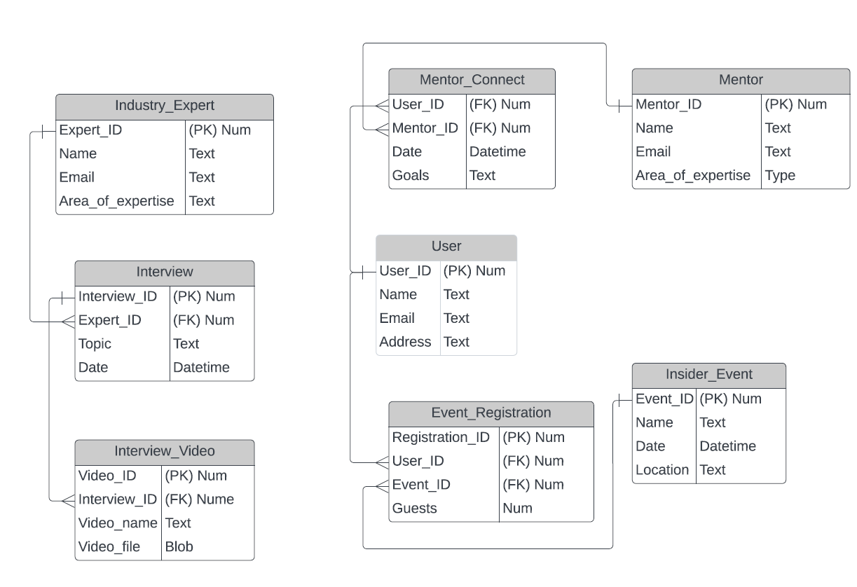
Notes and Ideas:
- User surveys and responses along with site data would further need to be analyzed to determine which topics are most popular among end users.
- More research is needed to determine the optimal number of interviews, mentors, and Insider Events to post up on the site, and how frequently they should be refreshed.
- Leveraging tools like Google Analytics would be useful for monitoring the website's performance.
- Anticipate building out processes to make importing existing data streamlined and more efficient, such as interviews that industry experts have done in the past or providing other legacy user data from older/or existing systems.

Domain:
For this database commissioning project, the domain name would be Industry Insider, see reference link below: https://senichol.webdev.iyaserver.com/idsn530/Sarah_Nichols_Assignment2.3.3_Group/

